Put Your Title Here, e.g. ASIANALYSIS-2020

Wen Chao^{1,2}, Chun-Hung Chang¹, and Jim Jr-Min Lin^{1,2}
1. Institute of Atomic and Molecular Sciences, Academia Sinica, Taipei 10617, Taiwan
2. Department of Chemistry, National Taiwan University, Taipei 10617, Taiwan

This is a sample document format for the one page extended abstract for submissions to the ASIANALYSIS-XV. Although this document is provided in Microsoft Word format, the paper to be uploaded must be in DOC or DOCX format. Paper size should be A4 format (210 mm x 297 mm). Margins should be set for a 2.5 cm top, bottom, left, and right. For text fonts: use only 10pt Times (roman, bold or italic), and Symbol. Sans Serif Fonts such as Arial can be used in Figures. All equations, drawings, figures and references are within the one page limit. Avoid asterisks, acknowledgements, job descriptions or footnotes. Do not add page numbers.
Simple equations should be included in-line wherever possible, whereas more complex expressions should be centred and numbered if there are several. Figures should be relevant to the submission and preferably centred as shown below. Placing subfigures side-by-side is a convenient way to include multiple results within the one page limit. Figure captions should be centred beneath figures and in an 8-point font. Figure captions should be indented 1 cm on both sides and justified on both right and left sides.

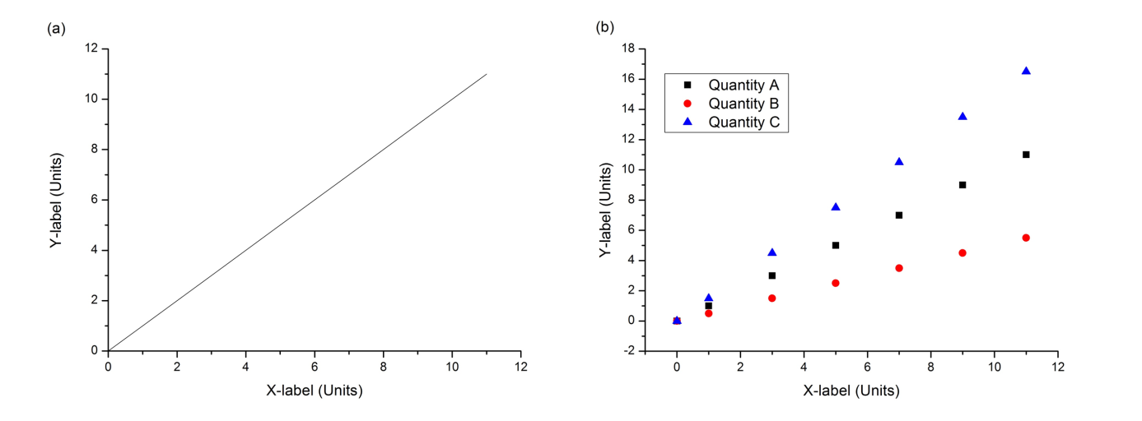

Fig. 1 The abbreviation “Fig.” with number should appear first (in bold) followed by the figure caption.

References should appear at the end of the article in the order in which they are referenced in the body of the paper. The font should be 8 point, and the references should be aligned left. Authors are listed first, followed by the full title in italic, the journal’s title abbreviation, the volume number in bold, page number, and the year in parentheses. Within the main text, references should be designated by a number in brackets [1], and they should precede a comma or period [2]. Two references cited at once should be included together [1,2], separated by a comma, while three or more consecutive references should be indicated by the bounding numbers and a dash [1,2].
References
[1] Wen Chao, Jun-Ting Hsieh, Chun-Hung Chang and Jim Jr-Min Lin, Direct Kinetic measurement of the reaction of the simplest Criegee intermediate with water vapor, Science 347, 751, (2015).
[2] Wen Chao, Jun-Ting Hsieh and Jim Jr-Min Lin, Another Example, Science 123, 1234 (2000).

